Taxes

Commit to learning about taxes and how to reduce your bill.
It is estimated that self-employed collectively overpay their taxes by $160 billion annually.
The average business owner overpays by $5000- $9000 annually.

Two Tax Binders With Six Major Headings

Binder One
Income

Binder Two
Divider 1 - Expenses
Divider 2 - Capital Costs
Divider 3 - Motor Vehicle Expenses
Divider 4 - Business Use of Home Expenses
Divider 5 - Other

Binder One

Income

Three sections in your income binder should include:
- T4A Profit
- Party Profit
- Summary of Income

Binder 1 – Section 1 - T4A Profit

- Rewards and Bonuses-

You will receive a T4A if your bonuses and rewards total past $500.
Your bonuses are:
- Personal volume bonus
- Team/Vanguard bonus
- Car Cash/Car Bonus
Your rewards are:
- Confident Start
- Party Perks
- Any other prizes offered
You need to claim this income – Line 020 on your T4A.

With this T4A, Tupperware also gives you a description/amount of what those items are, which is fantastic! You will want to photo copy it, use different colour highlighters, as some of these items you can use as a receipt for expenses in Binder 2 – I will explain later.

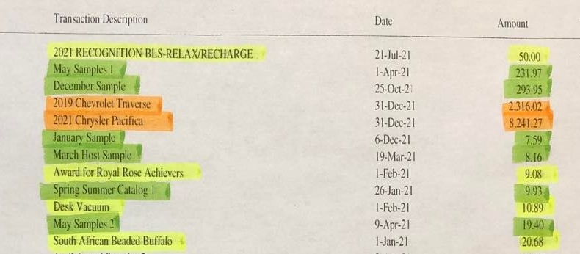

Binder 1 – Section 2 - Party Profit

Print out receipts for all parties, all individual orders, all web orders.
- Highlight your Retained Profit
- Circle any shipping expenses paid by you
- Anything you bought on these parties/orders, print out receipt as well and circle your expense.

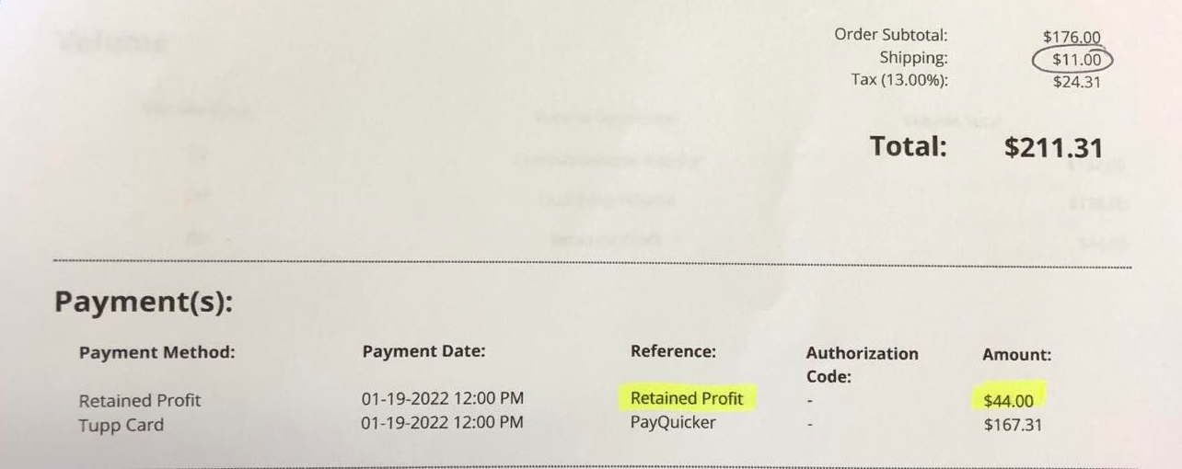
Print out your receipts weekly and put one week of business in a plastic sleeve with the cover page of the sleeve adding up totals. Here is an example…

Week 1/21
Dec 30 - Jan 5

Summary:

- Retained Profit $44
- Shipping Expense $11
- Purchases for my business $0

Retained Profit you will claim as income. Shipping Expense and Purchases you will claim as an expense in Binder 2. – I will explain later.

Binder 1 – Section 3 - Summary of Income

Total all weekly party profits for the year. Add this total, to your T4A total. This is your income for your Tax Year. Also total your shipping expense for the year as well as total your purchases for the year – this will be used in binder 2.

…And now the write offs

Binder Two

Divider 1 - Expenses

Headings to place in this section are:

Sub-Contractors
- cost of hiring outside help
- cleaning office
- babysitters when you go to work
- office help

Advertising & Promotions for Future Business
- adds
- posters
- publicity
- gifts as incentives for promotions to public

Professional Memberships and Subscriptions
- something you might subscribe to that helps you with your business

Delivery, Freight, Express
- stamps
- express post
- mailing
- purolating
- shipping costs (put your total here from Binder 1/Section 2 of your shipping expense for the year)
- etc.

Maintenance and Repairs
- computer repair
- building
- equipment
- etc.

Interest
- on loans
- credit cards
- credit lines
- bank accounts for business
- etc.

Management and Administration Fees
- bank charges

Meals and Entertainment
- eating out with clients
- gift certificates for team
- gifts for team
- shows
- spas
- food for events
- food for parties
- etc.

Office Expenses
- paper
- tape
- toner
- ink cartridges
- pens
- stamp
- ribbon
- tickets
- envelopes
- office organization things
- etc.

Supplies (consumed in the business)
- catalogues
- brochures
- key chains
- orange peelers
- game prizes
- etc.

Purchases
- Tupperware (put your total here from Binder 1/Section 2 - of your purchase expense) – Keep receipts in Binder 1 so that your weekly business stays together.
- T4A Rewards (put your total here from your highlighted T4A value of rewards you earned that you gave away as prizes for your customers, hosts, team) and use the highlighted T4A as your receipt

Legal, Accounting, and Other Professional Fees
- cost of your accountant

Cell Phone
- entire bill

Internet Fees
- Home internet
- Tupperware Web Site
- Etrends Newsletter
- 3rd Party Advertising (on websites) i.e. Signatures

Equipment Rental & Leasing
- signs for open house
- tables for cash n carry
- etc.

Research (as it pertains to your business)
- cable & satellite T.V.
- newspapers
- magazines
- CD’s
- DVD’s
- Books

Professional Development
- courses
- seminars
- fees for training (jubilee, super Saturday, etc.)

Convention Expenses
- includes trade shows
- etc.

Travel (Jubilee, Events, etc)
- public transportation
- airfare
- fares
- parking
- hotel fees
- food
- bus
- train
- taxi
- car rental
- etc.

Telephone
- business or fax line charges
- long distance plan (not home line charges)

Divider 2 - Capital Costs

(depreciable property like buildings, equipment, furniture used for your business that were purchased this year)

Headings to place in this section are:

Office Furniture
- desks
- filing cabinets
- etc.

Equipment
- photocopiers
- telephones
- appliances

Audio-Visual
- cameras
- projectors
- microphones
- recording equipment
- amps
- etc.

Computer Software
- not system software
- virus protection

Computer Equipment & Systems Software
- computer
- printer

Divider 3 - Motor Vehicle Expenses

Headings to place in this section are:

Year Make & Model

If acquired in this tax year
- copy of purchase agreement or lease agreement

Kms Driven
- total kms driven in year
- total kms driven for business (a log should be kept)

Gas & Oil
- gas
- oil
- wiper fluid
- etc.

Insurance

Maintenance & Repairs
- repairs
- tires
- etc.

CAA Membership

Tolls
- 407 bills

Interest On Car Loan

License & Registration
- plates
- sticker
- etc.

Leasing Costs

Car Washes

Business Parking Fees

Divider 4 - Business Use of Home Expenses

Headings to place in this section are:

Heat
- union gas bills

Home Owners Insurance

Maintenance & Repairs
- repairs on house
- repairs on office
- paint
- landscaping
- snow removal
- cleaning services
- etc.

Property Taxes
- yearly property taxes

Hydro

Water

Mortgage Interest (not principal)
- yearly mortgage interest

Security systems

Rent

Divider 5 - Other

Headings to place in this section are:

Canada Child Benefit (CCB)
T4 Employment
T4A Pension, Annuity, Employment
T4 RSP RRSP Income
T3 Trust Income
T5 Investment Income
Charitable Donations & Gifts
Medical Expenses Not Covered by your Insurance
Education
Etc – whatever pertains to you and your family

