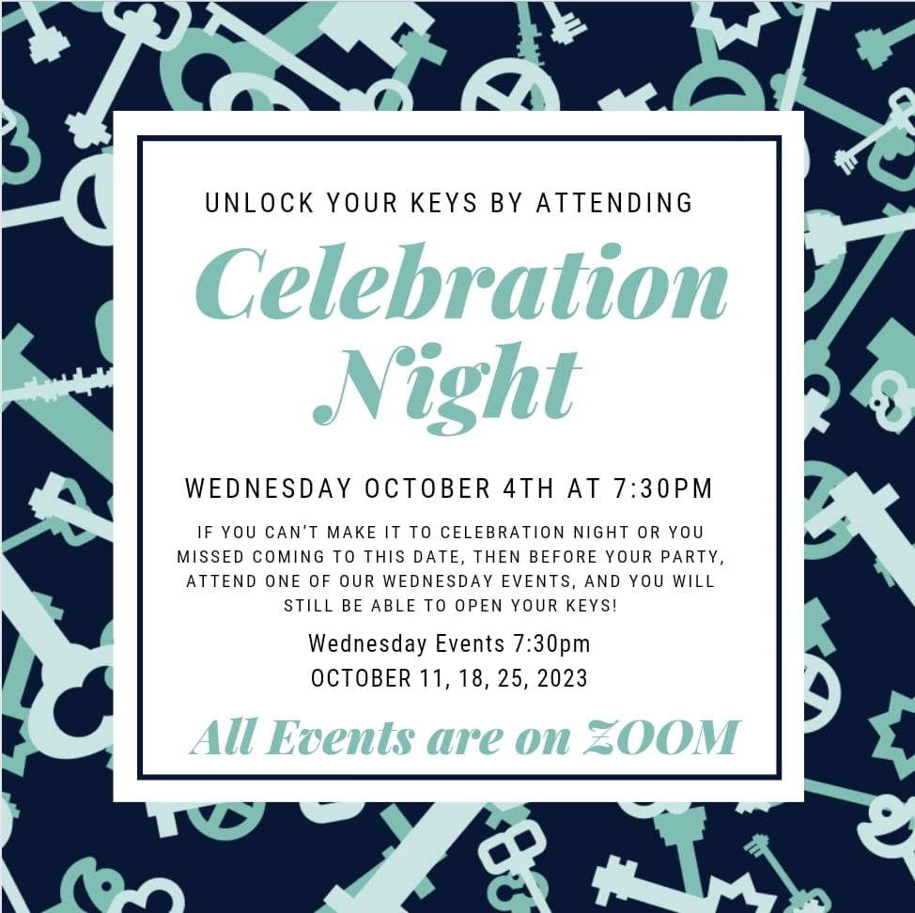

Hello October Hosts! Before your party, attend our “Celebration” Night October 4th and open your Keys!

Celebration Night

Date: Wednesday, October 4
Time: 7:30 to 9:00pm
Place: On Zoom

If you can’t make it to Celebration Night, then before your party, attend one of our Wednesday Events, and you will still be able to open your Keys!

Wednesday Events

Date: October 11, 18, 25
Time: 7:30 to 9:00pm
Place: On Zoom
Thank you for being an October Host! In celebration of you and your efforts, please attend your Celebration Night on Wednesday, November 1st, so we can reward you for a job will done!
Prizes are Awarded for…
Our Number 1 Host with the most points - $200 Product giveaway!
Top 10 Hosts in points
Top Host in each category
Tally Your Points
Tally Your Points:
Prior to your party, attended the Celebration & Guest Event or a Wed Event
__________ (200 points)
For each key you achieved
__________ (200 points/key)
For every advance order
__________ (100 points/advance order)
For 10 or more guests at your party
__________ (1000 points)
For every advance dating
__________ (100 points/advance dating)
For every dating off your party
__________ (100 points/dating)
For every toonie sheet completed
__________ (100 points/toonie sheet)
For every dollar sold
__________ (1 point/dollar)
Make your party a starter party
__________ (300 points)
Bonus for having a Home Party
​__________ (1000 point)

